
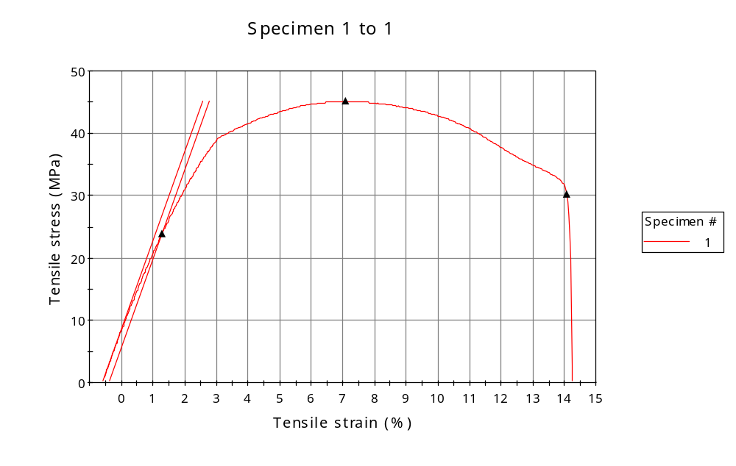
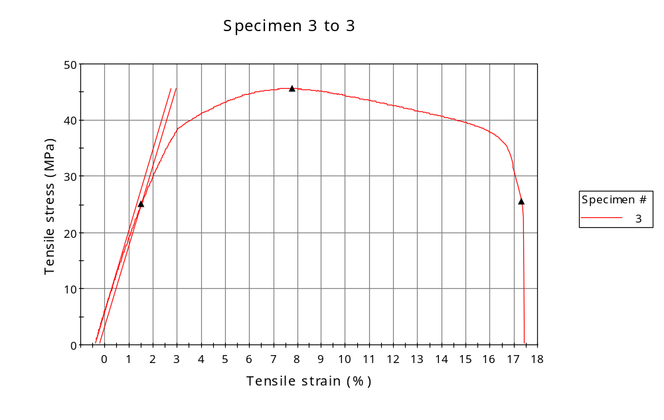
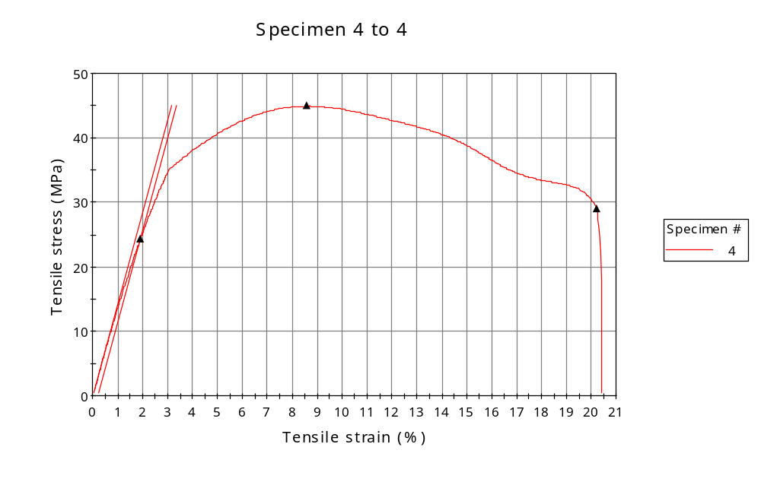
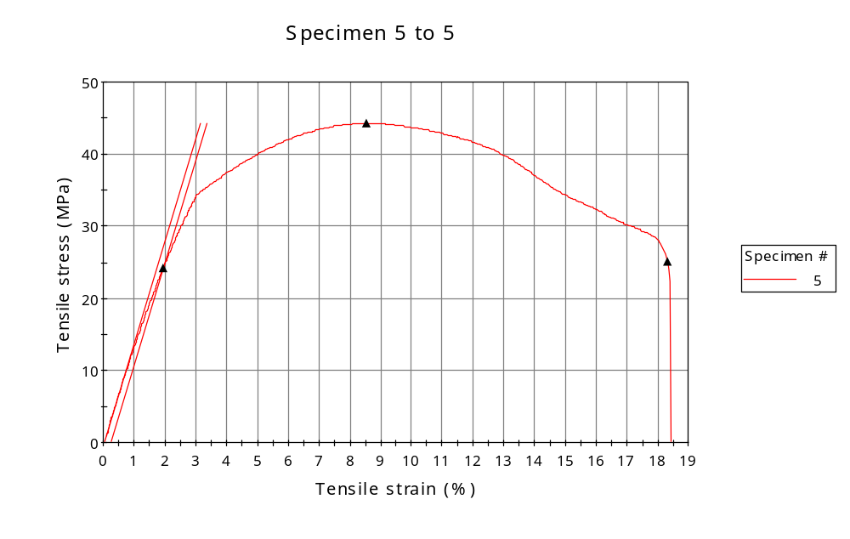
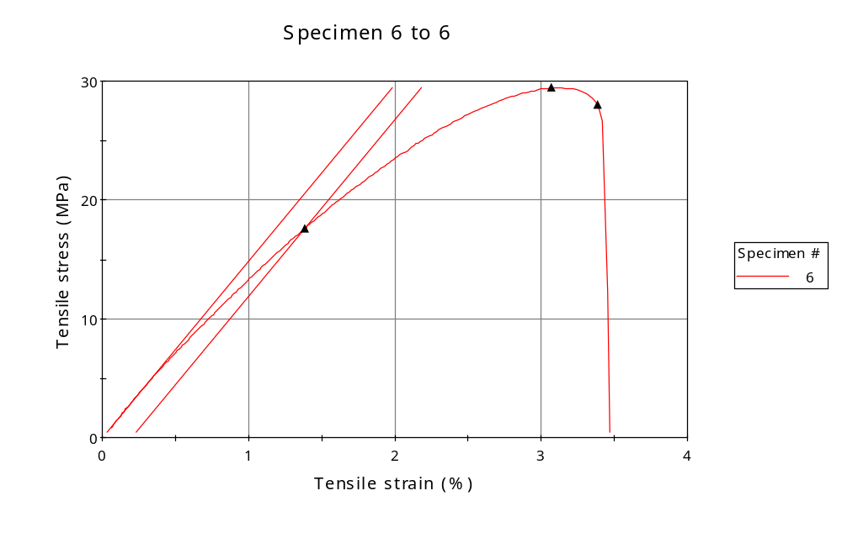
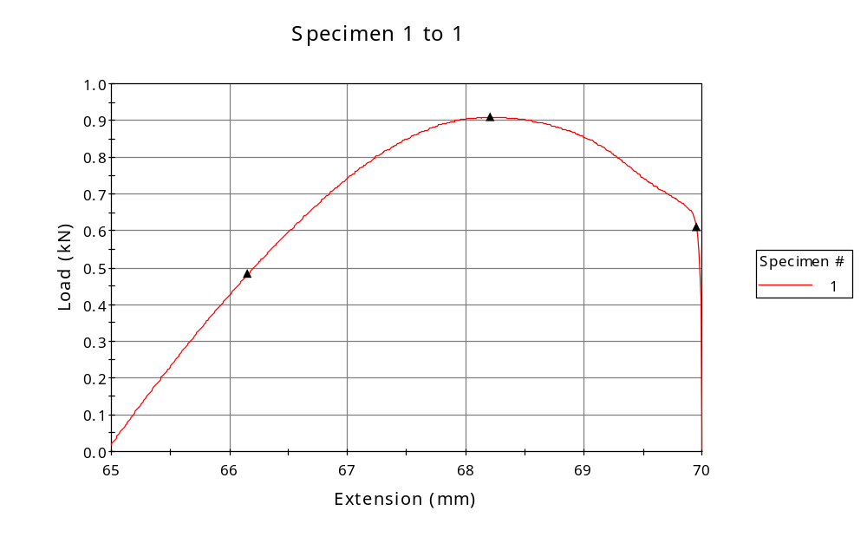
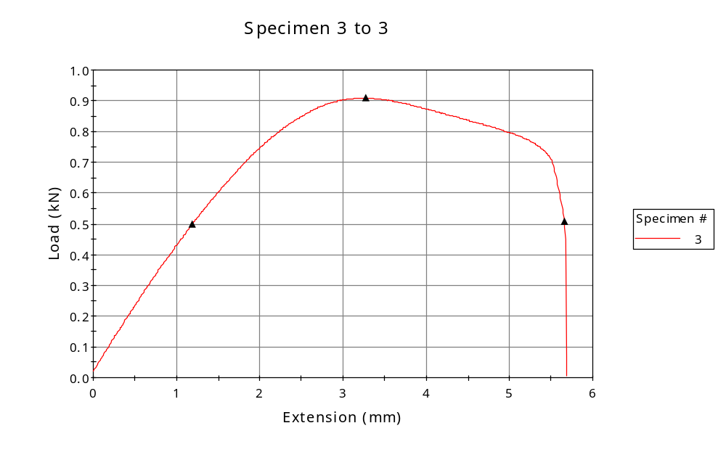
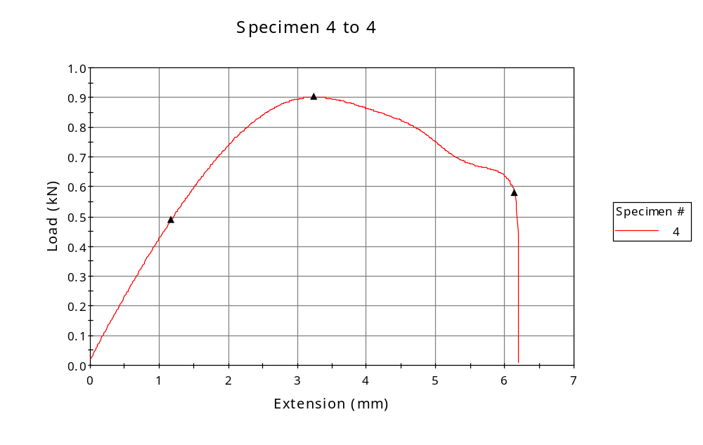
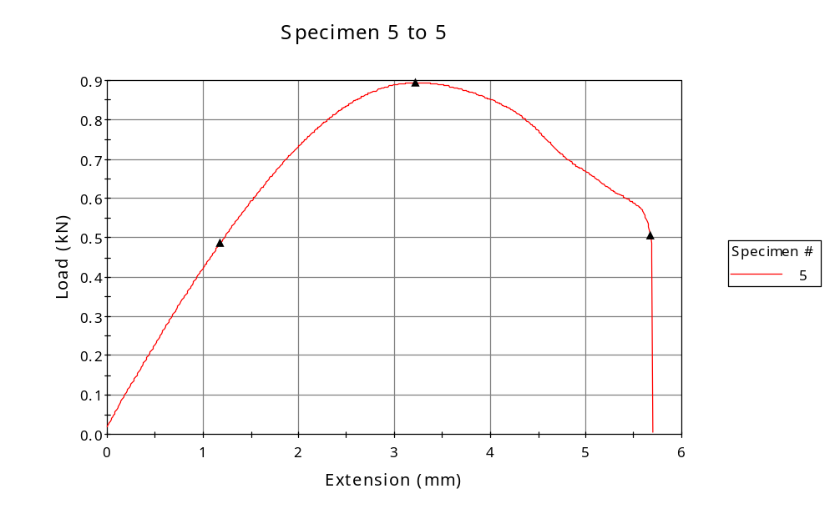
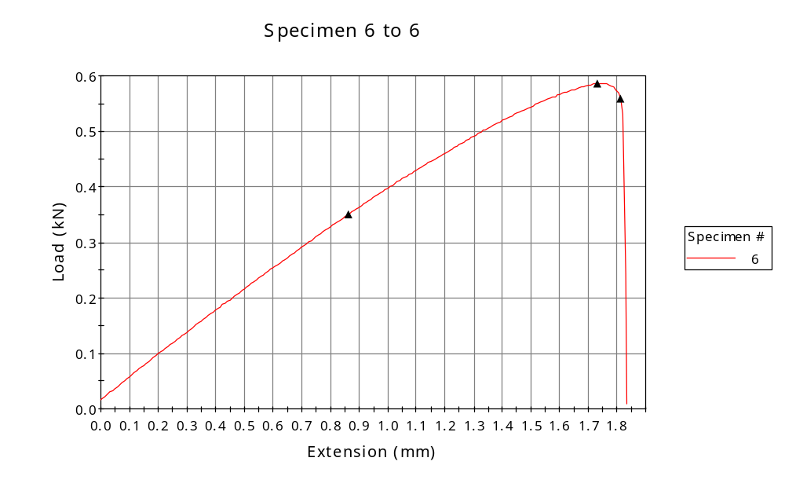

 | CP ID | Length  (mm) | Width  (mm) | Thickness  (mm) | Modulus (Automatic Young's)  (MPa)
1 | CP-01 | 25.00 | 5.97 | 3.38 | 1418
3 | CP-FDM-XY1_02 | 25.00 | 5.97 | 3.34 | 1430
4 | CP-FDM_XY1_03 | 25.00 | 5.97 | 3.36 | 1423
5 | CP-FDM_XY1_04 | 25.00 | 5.98 | 3.38 | 1413
6 | CP-FDM_XY1_05 | 25.00 | 5.96 | 3.34 | 1483
Maximum |  | 25.00 | 5.98 | 3.38 | 1483
Minimum |  | 25.00 | 5.96 | 3.34 | 1413

 | Load at Fy ( 0.2 %) - LE  (kN) | Tensao em Fy ( 0.2 %) - LE  (MPa) | Deformacao em Fy ( 0.2 %) - LE  (%) | Forca Max  (kN) | Tensao na Forca Max - LR  (MPa)
1 | 0.482 | 24 | 1.287 | 0.910 | 45
3 | 0.500 | 25 | 1.519 | 0.910 | 46
4 | 0.488 | 24 | 1.919 | 0.902 | 45
5 | 0.488 | 24 | 1.927 | 0.895 | 44
6 | 0.350 | 18 | 1.384 | 0.586 | 29
Maximum | 0.500 | 25 | 1.927 | 0.910 | 46
Minimum | 0.350 | 18 | 1.287 | 0.586 | 29

 | Deformacao na Forca Max - LR  (%) | Forca na Forca na Quebra - LQ  (kN) | Deformacao na Forca na Quebra - LQ  (%) | Final length  (mm) | Final width  (mm)
1 | 7.076 | 0.609 | 14.076 | 119.00 | 6.82
3 | 7.792 | 0.508 | 17.326 | 119.00 | 6.82
4 | 8.606 | 0.581 | 20.206 | 119.00 | 6.82
5 | 8.530 | 0.505 | 18.330 | 119.00 | 6.82
6 | 3.069 | 0.558 | 3.385 | 119.00 | 6.82
Maximum | 8.606 | 0.609 | 20.206 | 119.00 | 6.82
Minimum | 3.069 | 0.505 | 3.385 | 119.00 | 6.82

 | Alongamento
1 | 3.76
3 | 3.76
4 | 3.76
5 | 3.76
6 | 3.76
Maximum | 3.76
Minimum | 3.76

